TERM II SCIENCE P.5
COMPONENTS OF THE ENVIRONMENT
SOIL
TERMS USED
- Leaching – Is the sinking of nutrients into lower layers of the soil where plants roots can’t reach.
- Soil texture – Refers to different sizes of soil particles in an area.
- Soil structure – This is the way soil particles are grouped or arranged in an area.
- Soil sampling – Act of taking samples of soil from different areas in the garden with the aim of analyzing it in the laboratory
- Drainage – removal of excess water from a water logged area.
- Irrigation – An artificial method of providing water to crops in dry areas where there is no rain.
- Soil exhaustion – This is the loss soil fertility.
- Weathering – is the breaking of down of rocks into small particles to form soil.
- Soil erosion - Is the removal of top soil by its agents
- Crop – rotation – Is the growing of different types of crops on the same piece of land season after season.
- Mulching – covering of top soil in the garden with dry plant materials.
- Soil fertility – This is the ability of soil to provide plants with required nutrients for proper growth.
- Silting – Is the deposition of eroded soil into water bodies

The nature of soil and its importance to man
- It is a top layer of the earth’s surface in which plants grow
Importance of soil
- Provides food for growing plants (source of plant life)
- Source of water to plants and animals.
- Source of minerals
- Some soil is used for modelling, Brick making and construction
Soil profile
- Soil profile is the vertical arrangement of soil layers
- Layers of a soil profile
Top soil – it’s used for growing crops because it has a lot of humus
Sub soil
Parent rock –for road construction

Structure of soil profile

Top soils (Humus + loam)
Sub soil (clay + sand)
Parent rock (gravel)
Types of soil
Loam soil
- It contains organic matter
- It is the best soil for crop farming well drained and fertile because of the following
- It contains a lot of humus
- It contains balanced particles of sand and clay
- Its well aerated than clay and sand
- It has good soil texture
Clay soil
  - It has very small particles which are closely packed
  - It is sticky making it suitable for modelling (pottery) and brick making
  - It has very little humus
  - It retains water for a long time.
  - It has poor aeration
  - Has the highest capillarity and poorest drainage.
  - Have very small spaces between particles.
Sand soil
  - It has bigger particles
  - It has larger spaces between its particles.
  - It does not hold water for a long time.
  - It lacks humus and mineral salts
  - Used mainly for construction of buildings
  - Has the lowest capillarity and best drainage.
  - Experiment to investigate the type of soil which retains water for a long time
Materials you will need
    - Soil samples (Clay, Loam and sand)
    - Three (3) funnels of tee same size
    - Three (3) glass jars of the same size
    - Cotton wool
    - water
  - Experiments to investigate soil capillarity
Materials

- soil samples
- 3 funnels opened both ends
- water
- beaker

Procedure
- Put different samples of soil in different test tubes opened both ends
- Place then up right n a beaker of water
Observation
- The water moved to a higher level in clay soil, lowest in sand soil and moderate in lam soil
DIAGRAM
Experiment to show soil drainage

    - cotton wool
    - three funnels
    - soil samples
    - beakers

Procedures (steps)
  - Put cotton wool in each funnel
  - Put each type of soil in separate container
  - Place each funnel in a glass jar.
  - Pour some equal amount of water into the soil in each funnel
  - Observe what happens as water flows through each type of soil

A B C
Observation

  - What have you observed in each of the following three arrangements?
A___________B______________C______________
  - Name the soil labelled A and C.
  - Why the bottle with soil A in the funnel does contain more water than others?
  - Which funnel contains the best soil for growing crops?
Conclusion
We can therefore say that clay soil holds water for a long time.
How soil is formed
- It is formed in two ways namely;
- Weathering of rocks
- Decomposition (decaying of organic matter)
Weathering – is the breaking down of rocks into small particles to form soil
Decomposition – This is the breakdown of plant and animal remains to form soil.
Soil composition/soil components/elements of soil
These are things that make up soil
1. Organic matter (Humus) 4. Living organisms
2. Rock particles 5. Water
3. Dissolved mineral salts 6. air
NOTE
Components found in spaces of soil particles include;
- Water
- Air
Experiment to investigate that soil has both air and water
- Experiment to investigate that soil has water in it.
Things/materials you will need

  - Glass jar
  - Sample of soil (lump of soil)
  - Source of heat
  - Glass cover (condenser)

Procedure
  - Pour samples of soil in a container
  - Cover the glass container with a condenser
  - Expose the container to heat energy for about 5 minutes
Condenser
Water drops
Glass jar
Water vapour
Lump of soil (soil sample)

Source of heat
Observation
Conclusion: We can therefore say that soil contains water in it.
Experiment to investigate that soil has air in it.
Things/materials you will need

Lump of soil (soil sample)
Water
water jar

Procedure/steps
  - Get water in a beaker
  - Gently lower a lump of soil in a beaker containing water
  - Observe what happens

Water
Air bubbles
Beaker
Lump of soil

Observation
- Bubbles of air were seen escaping from the lamp of soil
Conclusion
- Bubbles represent air in the soil escaping from the lamp of soil

Soil erosion and its agents
- What is soil erosion? This is the removal of top soil by its agents.
- Agents of soil erosion are elements which cause soil erosion to take place such agents are;

- running water
-strong wind
- moving animals

Causes of soil erosion
- These are factors that make it easy for agents to carry away top soil such causes are;
- Overgrazing
- Deforestation

- Un controlled bush burning
- Over cultivation
- Mono cropping
- Cultivation along river banks
- Soil exhaustion etc

Prevention and control of soil erosion
- Afforestation
- Re-afforestation
- Terracing
Diagram of terracing
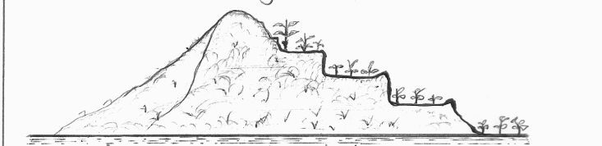

terraces

- Contour ploughing
- Re-afforestation and afforestation.
- Mulching
- Strip cropping
- Plant grass
- Bush fallowing.
Types of soil erosion
- Splash erosion – This is formed by rain drops hitting the ground and disperse soil particles.
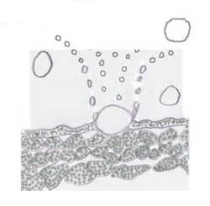
- Sheet erosion – This is where by which top soil is uniformly carried away by running water.
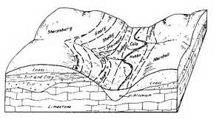
- Rill erosion – These are small channels made by running water on gently sloping piece of land. The small channels are known as rills.
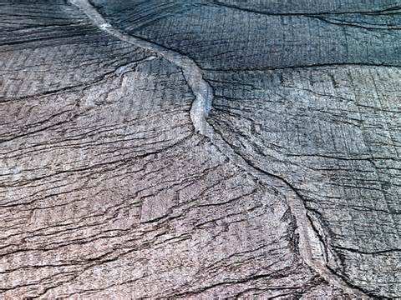
- Gully erosion – These are bigger channels formed by running water especially on hilly areas.
Soil conservation:
This is the protection of soil from losing its fertility.
Soil fertility
This is the ability of soil provide plants with nutrients required for plant growth.
Ways of conserving soil (ways of improving on soil fertility)
  - Mulching 5.Contour ploughing
  - Practicing crop rotation 6. Strip cropping
  - Practicing bush fallowing. 7. terracing
  - Adding fertilizers in the soil 8. afforestation

- Mulching _This is the covering o the top soil in the garden with dry plant materials.
- Mulches- are dry plant materials used for mulching.
Examples of mulches.
1. Coffee husks 2.maize stalks 3.dry grass 4.banana leaves
Advantages of mulching
  - It controls soil erosion.
  - Keeps moisture in the soil
  - It controls growth of weeds.
  - It improves soil fertility.
Disadvantages of mulching to the farmers
  - Mulches can easily catch fire and burn crops.
  - Mulches hide crop pests.
  - Undried mulches may grow into weeds.
  - Mulching requires a lot of labour.
Crop rotation (Ways of maintaining soil fertility)
- This is the growing of different types of crops on the same piece of land season after season.
Factors to consider when carrying out crop rotation
      - Crops with deep roots should alternate with those of shallow roots.
      - Crops of the same family should not follow each other e.g. don’t alternate maize with millet etc. this is to control pests
      - Legumes such as beans, ground nuts, soya beans alternate with other crops.
      - Put land to rest, this is called bush fallowing

Plot I Plot II Plot III
Beans Maize sweet potatoes 1st season

Plot I Plot II Plot III
Sweet potatoes Beans Maize 2nd season

Plot I Plot II Plot III
Maize Sweet potatoes Beans 3rd season

Advantages of crop rotation
    - Crop rotation controls pests in the garden
    - Parasitic weeds are controlled
    - It maintains soil fertility
    - Cover crops control soil erosion.
TYPES OF FERTILIZERS
- Artificial fertilizers.
- Natural fertilizers.
Artificial fertilizers (inorganic fertilizers)
- These are chemical elements/substances manufactured from industries.
- Common examples of artificial fertilizers
- NPK – Nitrogen phosphorous Potassium
- CAN – Calcium Ammonium Nitrates
- SSP _ Single super phosphate
- UREA – contains some element of nitrates.
Advantages of using artificial fertilizers
- They have high nutrients content
- They are easy to apply
- They are quick at improving soil fertility
Disadvantages of artificial fertilizers
- They can destroy both the soil structure and texture if used for a long time.
- They are expensive to buy.
- They stay in the soil for a short time
- Their application needs special skills.
- They pollute water when washed into water sources by running water.
Natural fertilizers ( organic fertilizers)
- These are called organic fertilizers because they are made from plants and animals remains
- Examples of natural manure are:

- Farm yard manure
- Compost manure
- Green manure

Farm yard manure: (FYM)
This is the type of manure which is got from animals wastes such as cow dung from cattle and droppings from goats, sheep, rabbits and poultry.
Green manure
- It is made from green crops such as maize, beans, peas etc.
- They are cut before flowering and ploughed back into the garden
Compost manure
- This is made from house hold refuse, weeds, plant remains and left over food.
- They are heaped in a pit to decompose, rot or decay before being applied on plants.
Compost pit cover

Compost manure Compost pit

Advantages of natural fertilizers

- It improves soil structure and texture
- They make soil hold water for some time.
- They release nutrients slowly

- Nutrients last longer in the soil
- It cannot spoil land

Disadvantages of natural manure
Nutrients take long to be released for plants to use
It produces a bad smell
They are tiresome to make (need a lot of labour)
It is not easy to collect plant and animal matter.
Effects of harmful materials on soil
Harmful substances that can affect the soil and make it lose its fertility are called Pollutants.
Harmful substance include the following;
    - Used engine oil 2. Polythene papers 3. Plastics 4. Metal scrap
Ways soil is polluted.
- Pouring used oil from Engines, factories etc to the soil
- Dumping or throwing polythene papers don’t allow water to enter the soil
- Dumping metal scrap on the soil
- Using pesticides to spray crops

Effects
- Oil kills the organism which stay in the soil
- Polythene papers, plastic and metal scrap prevent water infiltration into the soil

HEAT ENERGY AND MATTER
What is matter?
Matter is anything that occupies space and has weight.
Examples of matter

- Stones
- Water
- Air
- Human beings
- Soil

General properties of matter

- Matter occupies space
2. Matter has weight
- Matter is neither created nor destroyed

States of matter
Matter exists in three major states namely;

- Gaseous state of matter
- Liquid state of matter
- Solid state of matter

NOTE
- A molecule is a small particle that makes matter.
- Water is one of the substances that exist in the three states of matter.
GASEOUS STATE
Properties of gaseous state
- They do not have a definite shape.
- They occupy any space available.
- Heat travels in gases by convection.
- Molecules in gaseous state are mobile or furthest apart.
- Do not have cohesion forces.
Nature of molecules in gaseous state of matter
Molecules are mobile or furthest apart.
Simple diagram to illustrate

Molecules are mobile.

LIQUID STATE
Properties of solid state
- They do not have a definite shape.
- They take up the shape of the container in which they are put.
- Heat travels in liquid state by convection.
- Molecules are further apart.
- Cohesion forces are weak.
Nature (characteristics of molecules in liquid state of matter)
Molecules are further apart.
Simple diagram to illustrate

Molecules are further apart

SOLID STATE
Properties of solid state
- They have a definite shape.
- They have compact molecules or closely packed.
- Have strong cohesion forces.
- Heat travels by conduction.

Nature (characteristics) of molecules in solid state of matter.
Molecules are closely packed or compact.
Simple diagram to illustrate

Molecules are closely packed or compact.

MIXTURE
- This is a combination of two or more substances.
- Examples of mixtures
- Concrete: cement + sand + stone
- Porridge: maize flour + water
- ORS: Sugar + salt + water
Solutes (substances which dissolve in a liquid)
  - These are substances which dissolve in a solvent.
  - Examples of solutes
-Salt - sugar - glucose

- A solution: is a uniform mixture of two or more substances.
- A solvent: is a substance that dissolves a solute.
- Water is called a universal solvent because it dissolves most solutes.
- Soluble substances: are substances which dissolve in a liquid easily.
- Insoluble substances: are substances which do not dissolve in a liquid.
- Suspension: a substance which does not completely dissolve in a liquid.
- Saturated solution: Is a solution which cannot dissolve any more solute.
- Super saturated solution: Is a solution which cannot dissolve any more solute even after heating.

Separation of mixture
Separating mixtures of liquids and solids
- Decanting or decantation
This is a process of separating solid particles from a liquid.
Steps
- Put a mixture in a container
- Allow solid particles to settle at the bottom of the container
- Carefully pour off the clear liquid.
Note
- This method is used to obtain clean water from muddy water.
- Water obtained by decanting is not good for drinking because; decanting does not kill germs.
Diagram illustrating decantation

- Filtering or filtration method
- This is the process of separating solid particles from a liquid using a filter.
- The solid particles are called residue
- The clear liquid is called filtrate
- This method is used at home in two ways:
  - When preparing passion fruit juice.
  - When obtaining clean water from dirty water.
- Water obtained by filtration is not good for drinking because filtration does not kill germs.
Diagram showing filtration

- Separation of salt from sand by evaporation to dryness steps.
Steps
- Pour a mixture of sand and salt in water.
- Stir to dissolve salt.
- Filter to obtain a filtrate.
- Evaporate the filtrate to dryness
Qn: How can you obtain salt that has dissolved in water?
By evaporating the mixture to dryness.
Distillation
- This is a process of obtaining pure alcohol from crude alcohol
- It is also used to obtain safe water from dirty water (impure water).
- Distilled water is not good for drinking because it does not contain minerals salts.
- It is only used in mixing drugs for injections in hospital.

Simple diagram to illustrate the process of distillation
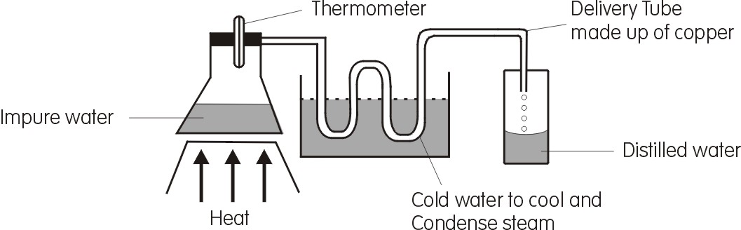

Separating mixtures of solids
- By floating – This method is used to separate a mixture where one sinks and the other float on water e.g.
- A mixture saw dust and sand
- A mixture of bad beans and good ones
- Using a magnet
This method is used to separate a mixture where one substance is magnetic and others are non – magnetic
- Hand picking or sorting
e.g. separating stone from rice, beans etc
- Sieving – This is a method used to separate large particles in a mixture using a sieve.
Diffusion
This is a process by which molecules move from an area of high concentration to an area of low concentration
- Examples

- Smoke diffuse into air
- Milk diffuses into water
- Salt diffuses into water
- Frying an onion
- farting
- Adding potassium permanganate in water (water becomes coloured)
- Maize flour (diffuses and then settles orange juice at the bottom)

Dilution
This is the process by which a concentrated solution is made weak
- Adding water to milk
Energy
Energy is the ability to do work.
Source of energy
The sun, running water, uranium, coal, plants, Dry cells, charcoal, petroleum, biogas, Natural gas
Types of energy
Potential energy
Mechanical energy
Kinetic energy
Potential energy
This is a type of energy possessed by bodies at rest e.g. a stone placed on a table.
Kinetic energy
This is a type of energy possessed by bodies in motion. E.g. A falling leaf from a tree
Experiments about kinetic and potential energy

Forms of energy
- Nuclear/Atomic energy
- Thermal energy
- light energy
- heat energy
- Solar energy
- Sound energy

HEAT ENERGY
Heat energy is a form of energy that has an effect on matter.
- Source of heat energy include:
- Natural source of heat
- Artificial source of heat
Natural source of heat
- sources of heat made by God
- Sun
- Empting volcanoes
- Lightning
- Natural gas
Artificial source of heat
- Source of heat made by man

- Electricity
- Burning wood
- burning charcoal
iv) Bio – gas
V) Friction

Uses of heat in our environment
- It makes both our bodies and houses warm
- Heat enables us to dry harvested crops and wet clothes
- Heat can kill some germs in our food and utensils
- It is used to cook food and boil water
- Heat is used during preserving of food.
- Heat is used to iron our clothes

Effects of heat on matter

- Evaporation
- Boiling
- Melting
- Burning

- sublimation
- increase in temperature
- Expansion of matter

NOTE
- When materials are heated they increase in size or volume. This process is called Expansion
- When materials are cooled they contract or reduce in volume or size.

Experiment to prove that when solid matter (metal) is heated it expands (becomes bigger, longer/change in size of matter
- Materials you will need

- Source of heat (stove)
- Stand
- Metallic round ball
- Metallic ring

2. Procedures /steps
- Get a metallic ball and a ring
- pass the ball through the ring
- Remove the ball in the ring and heat
- After heating the ball for sometime try to pass the ball again through the ring.
- Observe what happens.
Before heating After heating
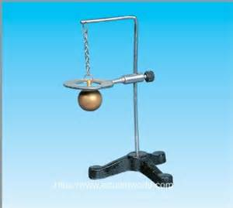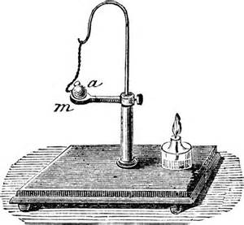
Heated ball
Cold ball
- When the ball was passed through the ring after heating failed.
- Because it had expanded.
- The above experiment shows that metals expand when heated and contract when cooled.

Expansion of gases
- Experiment to prove that when gases are heated they expand.

Materials you will need

- An empty flask (bottle)
- Glass tube
- Source of heat
- Water container

Diagram
Observations
- Bubbles of air were seen escaping descending.
Conclusion
- Air expands when heated

Expansion and contraction solid matter
Note
- When solid metals are exposed to sources of heat energy they tend to expand (become longer) and when exposed to cold conditions they contract (becomes shorter)
Applications of expansion and contraction of solid matter
- Gaps are left between rails of railway line to leave room for expansion on hot days.
Simple diagram to illustrate
After expansion gaps left for expansion
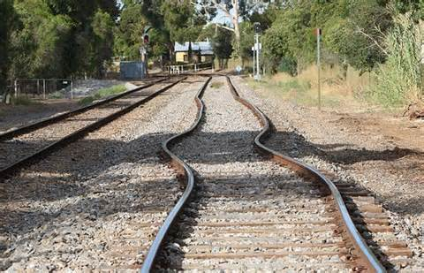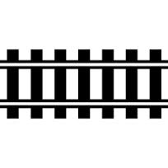
Contraction and expansion of bottled drinks
Space

The space above is left to leave room for increase in the volume of soda after freezing.
Electric and telephone wires
  - Electric wires/Telephone wires are left loose between poles to allow contraction on a cold weather.
  - They expand when exposed to hot weather and lead to bending (sagging).
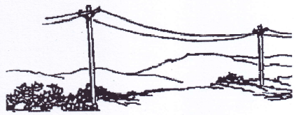

- Bridges are protected from bending by leaving gaps between metals bars. (The gaps leave room for expansions on hot days)
Disadvantages of too much expansion
- Wooden materials such as timber may bend
- Rails of railway lines bend when expansion is too much.
- Too much expansion makes walls building and wooden objects bend or crack.
- makes electric/telephone wire sag (lower)
Note: Sagging live electric wire can easily shock people and animals causing death
Disadvantages of too much contraction
- Makes electric wires tight and break.
- Makes the glass of a lantern or an electric bulb crack or break when exposed to cold water.
Control of too much expansion and contraction
- Avoid keeping glass bottled drinks in a refrigerator (freezer) for a long period of time
- Avoid leaving timber, furniture in sunshine
- Avoid pouring very hot liquid in glass containers
- Timber should always be dried slowly in sheltered/shaded places to prevent it from cracking or bending.
Change of matter from one state to another
- When matter is exposed/subjected to heat energy it tends to change from one state to another e.g.
- When solids change to liquids, the process is called melting
- When solids change to gases the process is called sublimation
- When Liquids to change solids, the process is called solidification.
- When Liquids to change gases the process is called evaporation
- When Gases to change liquids the process is called condensation
- When gases change to solids, the process is called deposition
Summary table
F
E
A B

D C
Name the process at
A B C D E
  - MELTING
- When solid substance as ice or solid kimbo is heated, it changes to liquid form. The process is called melting
(b) The process of Evaporation and condensation
    - Evaporation is the process by which liquids change to gas.
    - Condensation is the process by which gas changes to liquid.
Experiment to show the process of evaporation and condensation
1. Materials needed

  - Source of heat (stove)
  - Kettle
  - Water
  - Plate (condenser)

2. Procedure/step
(a) Pour some water (liquids) in a kettle
(b) Cover it and boil water for some time (up to boiling point of water)
(c) Place a plate condenser near the kettle outlet as hot water evaporates
(c) Observe what will happens
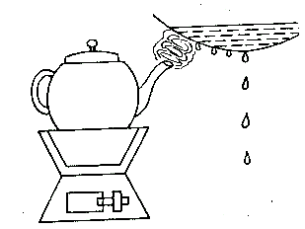
cold water in a container

A B
Kettle

charcoal stove
water droplets

Name the process at A and B
Observation
- At point A, hot water was seen evaporating and at point B water vapour turned into water drops.

Conclusion
- We can therefore say that water evaporated when heated by the process of evaporation and when water vapour cooled, turned into water drops by the process of condensation
Sublimation
This is the direct conversion/change of solids to gases.
Examples of materials which undergo sublimation
- Iodine crystals and sulphur
- Potassium permanganate
- Naphthalene balls etc
Heat transfer
- heat travels through solids by conduction
- heat travels through liquids and gases by convection
- Heat travels through vacuum or space by radiation

Experiment to prove heat travels through liquids by the process of convection
- Materials you will need

- water
- tea bag
- Beaker (water jar)
- source of heat)

- Procedure/steps
- Put some water in the jar
- Carefully drop a tea bag in water
- heat the jar containing water for some time
- Observe what happens
Beaker
Heavy molecules
Lighter molecules
Tea bag

Heat source

- Observation
- Lighter molecules move down while heavier molecules move upwards.
- This pattern of water movement in a beaker is termed as convectional current
- Conclusion
- We can now say that heat travels through liquids by the process of convection
Importance of heat transfer by convection in the environment
- Convection enables us to get Fresh air in our houses (circulation of air in the house).
- The continuous movement of air is termed as convectional current
Warm air comes out

Fresh air enters through the door and windows

Note! Heat can also move through gases by convection
- It helps to drive out bad smell in a vip latrine through the vent pipe

Simple diagram of VIP
screen

fresh air enters

Air circulation
faeces
pit

- Convection enables smoke to move out of the kitchen through the chimney.
- Convection helps to boil water
Charcoal stove will continue burning because of convection currents
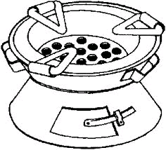
Holes to allow in fresh air
Holes to let out warm air

Conduction
- This is the process in which heat energy travels through solids
- Molecules do not move but just vibrate or shake.
Experiment to prove that heat travels through solids by conduction
- Materials you will need

- Metal rod
- candle wax
- wooden stand
- source of heat

- Procedure/steps
- Tie a metal wire on a wooden stand
- Place the balls of candle wax on a wire at intervals
- Observe what will happen to candle wax ABC

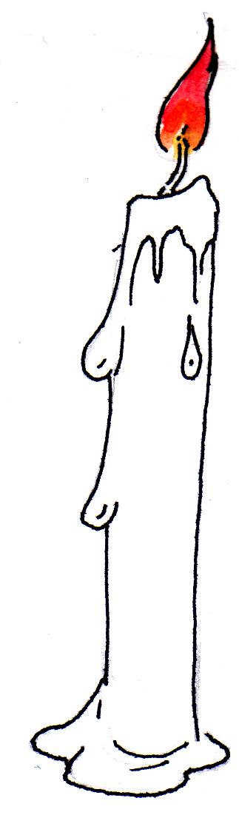
Wooden support
A
Heat source
Pieces of wax
B
C

Metal wire

Observation
- Piece of wax A melted first because it is nearest the source of heat
- Piece of wax c will melt last because it is furthest the source of heat
Conclusion
- We can therefore say that heat travels through solids by conduction.
Importance of heat transfer by conduction
- conduction of heat enables us to iron our clothes
- Conduction of heat enables us to cook food or boil water.
Good conductors of heat
Are materials which allow heat to pass through them easily
Examples of good conductors of heat.
- Silver 2.copper 3. Aluminium 4. Zinc 5. brass
Application of good conductors of heat
- Aluminium is used to make cooking utensils and electric wires.
- Iron is used to make the ironing part of a flat iron.

Bad conductors of heat (insulators)
- are materials which do not allow heat to pass through them
Examples of insulators
- dry wood 2.plastic 3. Rubber 4. Paper 5. Blankets 6.cotton wool 7. asbestos
Application of insulators in our daily life
- Some are used to make handles of cooking utensils.
- Are used to make clothes that keep us warm.
- Clay is used to make charcoal stove because it reduces loss of heat (bad conductors) of heat.
Simple diagram to illustrate
handle of kettle made of handle of iron box made of wood
plastic materials
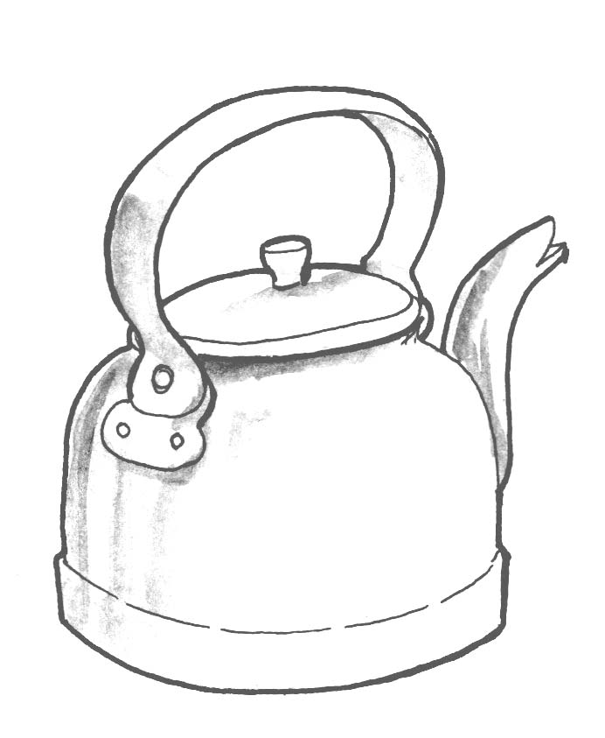
Conductivity of different material/substance
- Silver is the best conductor of heat (100%) followed by copper (90%) and aluminium (49%)
- Water is the worst conductor of heat (0.01%) and vacuum cannot conduct heat because it is just space without any matter.
- Why most house utensils are made of aluminium?

      - It is a good conductor of heat
      - it is very light (not heavy)
      - It does not rust very quickly
- It is cheaper compared to silver and copper

Water as the poor conductor of heat
An experiment to show that water is a poor conductor of heat.
test tube with water

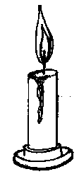
burning candle
ice cubes
cotton wool (wire gauze)

- Why does hot water remain on top of cold water as shown in the experiment?
- What does the experiment show?
- What shows that water is a poor conductor of heat?
Ice at the bottom did not melt yet water at the top is boiling.
Importance of heat transfer by radiation
- Radiation helps our clothes and harvested crops to dry.
- Help in sun bathing or basking.
- Radiation enables a person seated near a fire place to receive heat.
Heat reflectors and heat absorbers
  - When heat falls on a shinny surface, it is reflected
  - When it falls on a black surface it is absorbed.
Application of heat reflectors
- Refrigerators are painted white to reflect most of the heat.
- Storage tanks containing petrol are usually painted white to reflect most of the heat.
- Most building are painted white to reflect most heat
Note:
- A person putting on a black cloth will feel hot quickly because black absorbs heat.
- A person putting on a white shirt will not feel hot quickly because it reflects heat.

The thermos/ vacuum flask
- A thermos vacuum flask is a device used to keep hot substances hot and cold substances cold.
- Or maintain the temperature of what is put inside it.

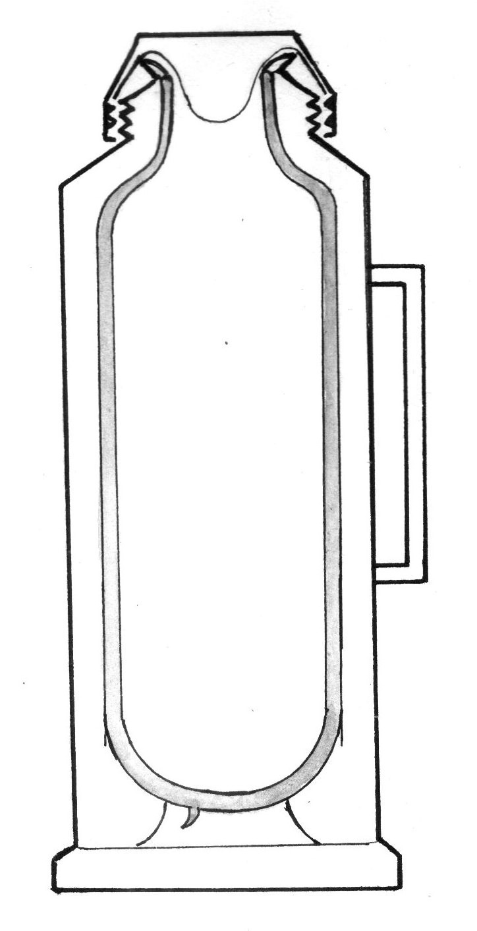
cork
cup
Vacuum
metal or plastic case
vacuum seal
cork case
double silvered walls

Functions of each part
- cork
It prevents the loss or gain of heat by conduction since it is an insulator
- Vacuum
It prevents heat loss or gain by conduction and convection.
- Double silvered walls
It prevents loss or gain of heat by radiation.
It is shiny to reflect heat
- Vacuum seal
It prevents any matter entering into the vacuum
- Cork base
It protects the vacuum seal from damage

THERMOMETERS
- A thermometer is a device used to measure temperature. It measures temperature in degrees centigrade (Celsius or Fahrenheit)
- Common types of thermometers are
  - Clinical thermometer
  - Wall thermometer
  - An ordinary scientific thermometer
  - Six’s ( maximum and minimum) thermometer
Clinical thermometer
- It is a device used to measure temperature of a human body.
- The normal temperature of a human body is 37⁰C or 98.4⁰F.
- Its scale runs from 34⁰C – 42⁰C or from 95⁰F to 110⁰F.
- This is because there are no human beings with a body temperature below 34⁰C or above 42⁰c

A simple diagram of clinical thermometer
Bulb with mercury
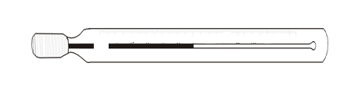
Constriction
Bore
Stem
Functions of each part
- Kink/constriction
-prevents back flow of mercury before temperature readings are taken

b) Stem
Provides the scale from which we read temperature.
It magnifies the mercury thread.

- Bore
It allows expansion and contraction of mercury
- Bulb
It keeps mercury
- Mercury
Only liquid metal which expands and shows temperature of a material/body
Note: The thermometer must be disinfected before it is used to another person
Adaptations of the clinical thermometer
- It has a kink that prevents back flow of mercury.
- It has a narrow bore in order to have accurate reading.
- Its scale runs from 34⁰c to 42⁰c.
Thermometer liquids
- Mercury
- alcohol
Reasons why mercury is commonly used in a thermometer
- It is easily seen(opaque)
- It has an even or regular expansion
- It does not stick on the sides of the bore
- It does not evaporate easily
- It is very sensitive to heat
Disadvantages of using mercury
- It cannot measure very low temperatures.
- Mercury is very expensive.
Reasons why alcohol is not commonly used in clinical thermometers
- It is not easily seen in the glass.
- It wets glass tube
- It is used only to measure minimum temperature.
Parts of a human body where a clinical thermometer may be put to detect/read temperature
- under armpits (c) In the vagina
- Under the tongue (d) In the anus
Note: The thermometer is put in the above parts to allow even expansion of mercury
The six’s thermometer
- This is also called maximum and minimum thermometer.
- It is used to measure the highest and lowest temperature of the day.
- It uses both alcohol and mercury for reading lowest alcohol and highest mercury
Diagram of the six’s thermometer
Min
Max
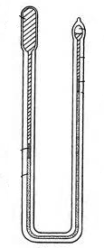
80
60
40
20
0
20
30
20
10
0
10
20
60
50
40
80
20
10
120
140
100
80
60
40
F
C
F

An ordinary scientific thermometer
This is a simple thermometer used in scientific experiments to regulate temperature
It is used in incubators
Wall thermometer 104⁰F
- It is used to measure room temperature.
- It uses both mercury and coloured alcohol.
- The room temperature normally reads up to 21⁰C or 22⁰C.
Temperature scales
- Centigrade scale
- Fahrenheit scale
Fahrenheit and centigrade scale conversion of temperature scales
- 0⁰C – 100⁰C
- 32⁰F – 212⁰F
- 0⁰C = 32⁰F (freezing point of water)
- 100⁰C = 212⁰F (Boiling point of water)
Calculations
Changing from centigrade to Fahrenheit scale
- To change from centigrade to Fahrenheit scale; multiply by ⁹/₅ and add 32.
Formula C⁰ = F⁰ = (cx⁹/₅) + 32
9C+160 = 5F (general or standard formula)
General formula

Examples
- Change 0⁰C to Fahrenheit scale
⁰F = ⁹/₅ C + 32
⁰F = ⁹/₅ x 0 + 32
⁰F = ⁰/₅ + 32
⁰F = 0+32
O⁰C = 320F
- Change 100⁰C to Fahrenheit scale
= (C x ⁹/₅) + 32
= (100 x ⁹/₅) + 32
= (20x9) + 32
= 180 + 32
100⁰C = 212⁰F
General formula (9c+160) =5F
General formula 9c = (5F-160) or ⁰F = ⁹/₅C + 32
- Change the following Celsius to Fahrenheit scale

- 60⁰C
- 40⁰C
- 15⁰C
- 45⁰C

Changing from Fahrenheit to centigrade scale
To change from Fahrenheit to centigrade scale: Subtract 32 and then multiply by 5/9
Formula ⁰C = ⁵/₉ (⁰F – 32)
Examples
- Change 32⁰F to centigrade scale
C⁰ = ⁵/₉ (F – 32)
= ⁵/₉ (32 – 32)
= ⁵/₉ (0)
= (⁰/₉)
= 32F⁰ = 0⁰C
Change 212⁰F to centigrade scale
- F⁰ – C⁰ = ⁵/₉ (F – 32)
= ⁵/₉ (212 – 32)
= ⁵/₉ (180)
= 5x20
212⁰F = 100⁰C

- Change the following Fahrenheit to centigrade scale

- 95⁰F
- 59⁰F
- 86⁰F
- 113⁰F
- 104⁰F

BURNING
Burning is a chemical reaction in which heat and light produced with help of oxygen.
regions of a burning candle flame.
Yellow zone
un burnt gas
Candle wax
blue zone

pale blue zone

Blue zone

    - Is the outermost part of the flame.
- Complete burning takes place here.
- It receives enough oxygen since it is the outermost region.
Yellow zone

- It’s the brightest zone/part of the flame
- It gives out light
- Incomplete burning takes place here
- It does not receive enough oxygen
Pale blue

- It receives enough oxygen by convection currents

Un burnt gas
- This region does not burn
- It does not receive any oxygen
- It does not produce heat and light.

- Experiment to show that oxygen supports burning
glass jar

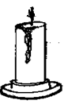
bunring canlde
The candle goes off agter a short itme ebacsue oxygen is used up by the burning candle.
Experiment to show which part of air is used during burning
Materials

water
candles
measuring cylinder
beaker

Procedure
Half a beaker with water
Fix candle in the basin and light it
Cover the burning candle with a measuring cylinder

candle wax
measuring cylinder
water
Observations
After a short time, the candle goes off and water is found to have risen in the measuring cylinder B.
Conclusion
The candle went off because the gas oxygen which supports burning was sued up.
During burning oxygen is used as carbondioxide is produced.
water raised to replace the space for the used oxygen

Ways of putting out fire
Using fire extinguishers
Using water for fires not caused by petrol
Rusting
Rusting is the oxidation of iron to from a brown oxide
Conditions necessary for rusting
Oxygen
Water/moisture
Disadvantages of rusting

It wears out iron and steel equipments
Spoils the colour of things
Water in rusty containers is poisonous
keys fails to fit in padlocks after rusting

How to prevent rusting

Oiling or greasing metals
Painting metals
galvanizing iron
Enameling iron
Making iron stainless steel

CROP GROWING
Root tubers
A root tuber a swollen underground root that stores food for the plant
Examples of common root tubers

cassava
carrots
turnips

Stem tubes
Stem tubers are swollen underground stems that store food for the plant
Examples of common stem tubers
Irish potato
White yams
Growing and caring for stem and root tuber crops
Sweet potato
It stores food in the roots
Its propagated by planting stem cutting or vines
Ways of caring for sweet potatoes

By weeding
By spraying
By pruning

Disease of sweet potatoes
Potato blight – It causes brown dead patches on the leaves
control – plant vines free from pests
Bacterial blight – affects leaves of potatoes
Sweet potato pests

Potato weevils
Caterpillars
Butterflies
moths
rodents
wild pigs
goats, cows

Ways of controlling pets of sweet potatoes

By spraying using pesticides
Planting clean varieties
use of scare crows
crop rotation
uprooting infected ones

Cassava
It stores food in the rots
It can be propagated by planting stem cuttings
Care for cassava

weeding
spraying
pruning

Disease of cassava
Cassava Mosaic
Its caused by a virus
Causes yellowing of leaves
Control
Plant materials free from pests
Destroy the infected plant materials
Brown streak
Its caused by a virus
Brown patches are found inside the cassava tuber
Control
Plant healthy materials
Destroy diseased plants
Brown streak
Its caused by a virus
Brown patches are found inside the cassava tuber
Control
plant healthy materials
destroy diseased plants
Cassava pests

white fly
green cassava mites
grass hopper
caterpillars

Carrots and turnips
Carrots store food in the roots
They are a good source of vitamin A needed for good eye sight
Carrots are propagated by using seeds
Disease and pests of carrots
Aphids – They attack the bases of the shoots
Nematodes – severely damage roots, causing swelling
Ways of controlling disease and pests of carrots
By planting healthy carrot and turnip seeds
By spraying using pesticides
Growing stem tubers
Irish potatoes
It stores food in the stem
its propagated by planting the stem tuber
Disease of Irish potato
Bacterial wilt – destroys leaves and turns they become pale yellow.
Control
practice crop rotation
use resistant varieties
Pests of Irish potatoes
Potato aphids
Rats
Monkeys
White yams
They store their food in the stem found underground
They are propagated by using stem tubers

Diseases
Bacterial blight
Examples of pests which affect root crops

caterpillars
rodents
monkeys
rats
grasshoppers
wild pigs

Characteristics of common tuber crop pests
Pests of leaves and stems
Have mouth parts for cutting and chewing leaves
they are mainly insects
Examples

caterpillars
army worms
sweet potato weevils

Pests of roots
Have sharp claws which help to dig the soil
Have sharp incisors to bite roots.
Some have fingers for uprooting the hole plant
Have teeth used for chewing
Examples

Monkeys
Rats
Moles

Ways of control

using scare crows
poisoning
trapping

Signs of diseased crops

Stunted growth
Poor quality of yields
Yellowing of leaves

Effect of pests and disease on tuber crops

They destroy leaves stopping food making
The eat tubers and destroy them
they make tubers rot
Some eat the stems of the tuber crops

Methods of controlling pests and disease of tuber crops

By spraying using pesticides
By used of scare crows
Planting clean resistant varieties
Uprooting and burning infected plants
Practicing crop rotation

Ways of harvesting tuber crops
digging e.g. sweet potatoes, Irish potatoes
Uprooting e.g. cassava
Ways of processing tuber crops
Cassava can be peeled dried and processed into flour
sweet potatoes can be peeled and dried for storage
Ways of storing tuber crops
Cassava and sweet potatoes can be peeled dried and then stored in granaries
Dried pieces of cassava and sweet potatoes can also be stored in sacks put on raised stands

Science oriented clubs
Young farmers’ club
Young farmers are young people in a school or community who have interest in farming and practice farming methods
They can grow crops in small garden and rear animals like rabbits, poultry
Roles of young farmers
- They grow crops which can be eaten by the school
- They help to improve methods used in farming within the community
- They organise for study trips to bigger agricultural organisations
- They crop products can be sold to other people and the school gets money
- They help to teach their fellow children in the school better methods of farming and how to grow crops
Note: Young farmers can be assisted by a bigger body called the cooperative society
Importance of co-operative societies
They supply improved seeds to young farmers clubs
Transport young farmers produce to markets
Give small loans to young farmers
They provide farm equipments to young farmers at reduced costs
They give advice and training to the young farmers on the bests methods of farming
Examples of co-operative societies

Bugishu co-operative society
West Mengo cooperative societies
Busoga growers cooperative union

Examples of single celled animals
Bacteria (many), one (bacterium)

Virus
Protozoa

Bacteria
They are single celled organisms
They can’t be seen by our naked eyes instead we use a microscope to see them.
Characteristics of bacteria
They are single celled organisms
They don’t have a regular shape
They can’t be seen with naked eyes
Habitats of bacteria (where they live)
water
air
blood
mucus
soil
rotting matter
contaminated water
Movements of bacteria
Some bacteria move by the help of flagellum.
Structures that help bacteria to move
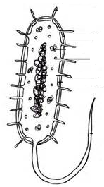

flagellum
cilia

Breeding/reproduction of bacteria
Bacteria breed, reproduce by the process called binary fission.
Where bacteria breed
In latrines
On rubbish pits

Conditions of bacteria to breed
Warmth
Food
Moist places
Simple diagram to illustrate how bacteria multiply
daughter cells

parent cell

Feeding of bacteria
Bacteria mainly feed in two ways
Parasitically.(feed on a host)
Saprophytic ally(absorb nutrients from decayed matter)
Types of bacteria
Bacteria are grouped in accordance to their shapes eg
Spherical in shape
Spiral shaped
Rod shaped bacteria
(a) The spherical bacteria
These are called cocci or coccus. These cause boils, sore throats, Pneumonia etc
Strepto cocus
(causes sore throat blood poisoning)

staphylococus
(causes boil)

strepto coccus – diplococus (cocci)

(b) Rod shaped or cylindrical bacteria
They are called Bacilli

(c) Spiral shaped bacteria
These are called spirilli (spirilla)

Respiration of bacteria
Some bacteria use oxygen for respiration. The y are called Aerobic bacteria
Others do not use oxygen for respiration. These are called Anaerobic bacteria
How do bacteria enter in our bodies?
- They enter in our bodies through

Un – cooked food we eat
Handling food with un-washed hands
Air we breathe in
Cuts/wound on our bodies
Drinking contaminated water

Useful bacteria
These are said to e useful because of the following reasons
Nitrogen fixing bacteria help in nitrogen fixation.
Some help in decomposition of organic matter.
Help in production of vinegar (Vinegar is a substance used to preserve foods such as meat)
Some bacteria found in the alimentary canal, help in digestion of food
Some bacteria help in production of bio-gas etc
Some bacteria are used to make vaccines like BCG vaccine.
Harmful bacteria
Ways bacteria are hamful.
They cause diseases to animals and plants
Bacteria makes food to go bad
Some make wounds septic.

Methods of combating/fighting bacteria
Carryout immunization to prevent immunisable disease caused by bacteria
Cooked must be covered properly
Drinking clean boiled water
Handle food with clean hands
Personal hygiene should be observe
Proper disposal of wastes (using latrines and toilets)
Use of disinfectant such as Jik to clean toilets
Living in a well ventilated house
Abstain from sex.
Use of antiseptics e.g. Medicated soap Dettol, iodine
Use of ant – biotics e.g. Penicillin
By preserving food.

People who made great discoveries in science (Pioneers)
(a) Edward Jenner (1749 – 1895)
He was the first English doctor to immunize some one against smallpox.
(b) Louis Pasteur (1822 – 1895)
Discovered that fermentation, decay and various diseases are called by bacteria.
He discovered pasteurization of milk (boiling milk to the highest temperature)
(c) Sir Ronald Ross (1857 – 1932)
He was the first scientist to discover the cause of malaria.
(d) Sir Alexander Fleming (1886 - 1985)
He discovered penicillin which prevents the growth of disease germs
(e) Joseph Lister (1827 – 1912)
He discovered the antiseptic which prevents wounds from becoming septic (have pus in them)
(f) Robert Koch (1843 – 1910)
He was a German medical doctor who studied the cause of anthrax and discovered the bacteria responsible for the cause of tuberculosis and cholera
(g) Sir William Harvey (1578 – 1657)
He was an English doctor who studied how blood circulates around the body.

FUNGI
These are organisms which do not contain chlorophyll and therefore can’t carry out photosynthesis.
Fungi are not plants because they do not make food.
Fungi are unable to make food because they do not have chlorophyll.
Fungi are called saprophytes because they absorb nutrients from decayed matter.
Examples of fungi.

Yeast
Moulds
Mushrooms
Toad stools
puff balls
Bracket fungi

Characteristic of fungi
They don’t have chlorophyll
They obtain the food from decaying matter (saprophytically)
Most fungi have many cells (multicellular).
Fungi reproduce by means of spores and budding in yeast.
Importance of fungi (useful fungi)
Some fungi like mushrooms are source of food for human beings
Yeast is used in fermentation of alcohol
Some fungi are used to make penicillin drug.
Yeast is used to bake bread and cakes.
Fungi help in decomposition of organic matter.

Examples of fungi
(a) Mushroom
Mushrooms are common fungi that grow during rainy seasons
They grow on pieces of wood, around cow dung, brew refuse and other organic matter
They feed saprophytically
They reproduce by means of spores
Some can be eaten by man and others are poisonous.
Some are used in production of medicine

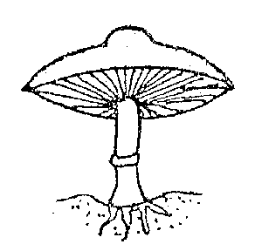
cap

gills

r rings

mycelium

Functions of each part
Cap
It protects the inner structure of the mushroom such as gills
Gills
They are responsible for producing and storing spores
Ring
It holds the cap to protect the gills when developing
Mycelium
Acts as root system
It absorbs nutrients from decayed matter
Stalk: Holds the cap in upright position
(b) Moulds
These grow on rotten plants and animals such as cassava pieces, bread etc
(c) Toad stool
They grow on ground or old tree stumps during rainy seasons
They resemble mushrooms
They feed saprophytically
They are poisonous
(d) Yeast
These are singles celled fungi on the surface ripe fruits such as mangoes
They reproduce by budding of cell.
budding of yeast cells

(e) Penicullium
These belong to group of fungi
It is used in making anti-biotic called penicillin.
Harmful fungi (Fungal diseases)
- They are harmful because of the following reasons;
Moulds make food go bad.
Some fungi destroy wood and its products
Some fungi are poisonous like toadstools.
Some fungi cause diseases to both animals and plants
NOTE
All disease caused by fungi are called fungal diseases.
Fungal diseases in people
Ringworm infection candidiasis
Athlete’s foot
Fungal diseases in plants
cotton root rot tomato blight
coffee berry disease
Prevention of fungal diseases or control of fungal diseases
a.In people
Observe proper personal hygiene.
Avoid sharing clothing.
b. in plants.
Preserving food.
Store food in cool dry places.
Spray using fungicides
Similarities between fungi and bacteria
Both cause diseases to people and plants.
Both carry out decomposition of organic matter.
Both feed on dead decayed matter.
Differences between bacteria and fungi
Bacteria fungi
Bacteria reproduce by or binary fission - fungi reproduce by means of spores or budding
Some bacteria make their own food - fungi don’t make their own food
Most bacteria have one cell - most fungi have many cells.

